**Wentworth Institute of Technology**

**Comp650**

**Senior Project in Computer Science**

**Summer 2012**

**Members:** Arthur Charlton, Alex Jackson, Timothy Brantley II

**Project:** Multisaver

***Summary of Proposal*:** Multisaver is a project intended to give users with multiple monitors a robust suite of screensaver tools. To do this, the team will be utilizing the XNA Framework to develop

***Design:***

The project will be broken into the following components:

**1. Configuration/Settings Module**  - This will be a WPF driven User Interface for the various settings users can configure. It will:

a. Assign Monitors to Groups

b. Activate and Deactivate Groups

c. Set a Group's display type

d. Change Settings for a Group

e. Change Settings for a Monitor, based on the display type of the Group

f. Save and load Settings to an XML file

**2. Slideshow Module** – This will be a series of XNA classes driving the Slideshow. It will interface with the Display Module to display pictures based on the following options, which it will read out of the XML file saved by the Configuration Menu:

a. Transition Mode – How the pictures will move on, off, and between the screens

i. Fade – the picture will fade in and out

1. Fade Time – The amount of time it takes to fade in and out

2. Display Time- The amount of time the picture stays on the screen

ii. Pan – The picture will slide to or from one side of the monitor

1. Pan Time – The amount of time it takes to reach the center

2. Display Time- The amount of time the picture stays on the screen

3. Direction In – The direction the picture will come from

4. Direction Out – The direction the picture will leave

iii. Spiral – The picture will spiral out from the center of the screen

1. Fade Time – The amount of time it takes to spiral in and out

2. Display Time- The amount of time the picture stays on the screen

3. Direction – Whether the picture spirals clockwise or counter clockwise

4. Rotation – The number of rotations the picture will make on its way in or out

b. Album – The windows folder that holds the pictures to display

i. Order – The order to display the pictures in the folder

1. Alphabetic – Pictures will be displayed in alphabetical order

2. Reverse Alphabetic - Pictures will be displayed in reverse alphabetical order

2. Random – The pictures will be displayed in a random order

**3. Maze Module –** A series of XNA classes driving maze creation and display. It will interface with the AI Module for AI location and traversal and the Display Module to display pictures based on the following options, which it will read out of the XML file saved by the Configuration Menu:

1. View – How the maze will be displayed on each monitor

a. Top Down – The whole maze is displayed at once, with markers indicating the location of each AI

i. This view will be restricted to 1 monitor per group in the Configuration Menu

b. First Person – The maze will display from the point of view of an AI

i. AI – The AI whose view is being displayed

ii. Direction – The direction the camera will face from the AI's location

2. Size – How big the maze is

3. Pallet – The color and texture displayed on the maze walls

**4. AI Module** – A series of XNA classes to track AI location and traversal for the Maze Module. Time permitting it will have the following options, which it will read out of the XML file saved by the Configuration Menu:

1. Methodology – The logic utilized by the AI to solve the maze

a. Depth First – The AI will perform a Depth First Search of the maze until reaching the end

b. Breadth First - The AI will perform a Breadth First Search of the maze until reaching the end

c. Left Hand Rule – The AI will make a left turn at every junction, ignoring paths it has been down and backtracking upon dead ends

**5. Display Module –** This Module will display the screensaver to the screen. It will interface with the Maze and Slideshow Modules to determine what images to display, and read from the Configuration XML to know what modes to display on which monitors.

Fig 2.1 - Configuration Window Mockup

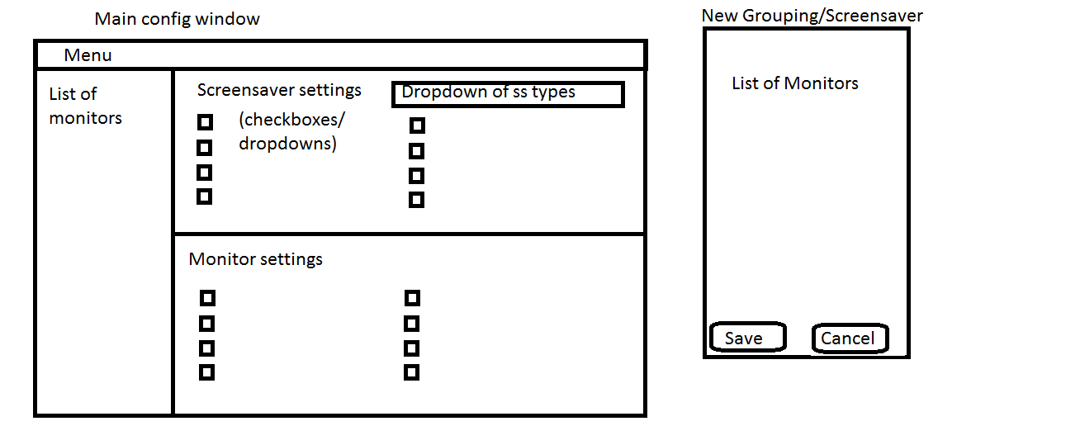

Fig 2.2 - Class Diagram

